Program -6

**Aim: Selection Sort and Insertion Sort in Python.**

**Code:**

**Selection Sort:**

def selectionSort(array, size):  
 for step in range(size):  
 min_idx = step  
 for i in range(step + 1, size):  
 if array[i] < array[min_idx]:  
 min_idx = i  
 (array[step], array[min_idx]) = (array[min_idx], array[step])  
data = [-2, 45, 0, 11, -9]  
size = len(data)  
selectionSort(data, size)  
print('Sorted Array in Ascending Order:')  
print(data)

**Output:**

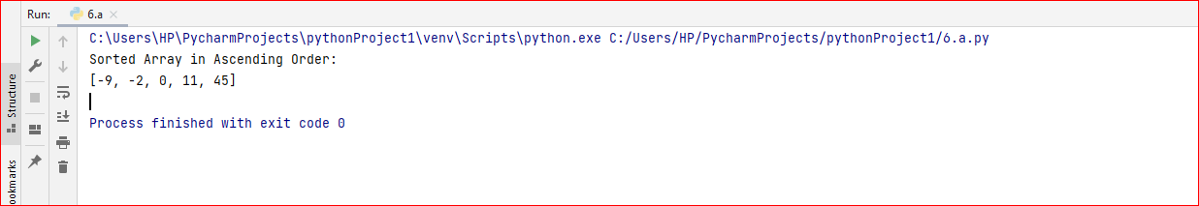

**Insertion Sort:**

def insertionSort(array):  
 for step in range(1, len(array)):  
 key = array[step]  
 j = step - 1  
 while j >= 0 and key < array[j]:  
 array[j + 1] = array[j]  
 j = j - 1  
 array[j + 1] = key  
data = [9, 5, 1, 4, 3]  
insertionSort(data)  
print('Sorted Array in Ascending Order:')  
print(data)

**Output:**

